# BC&D CMS MANUAL

Table of Contents

BC&D CMS MANUAL 1

Language Setting 2

Menu Setting 3

Home Page Slider Setting 4

About Page Setting 5

Gallery Category Setting 6

Gallery Setting 7

News Setting 10

Contact Setting 13

Meta Tag Setting 14

Social Media Setting 15

www.po.st Setting 16

# Language Setting

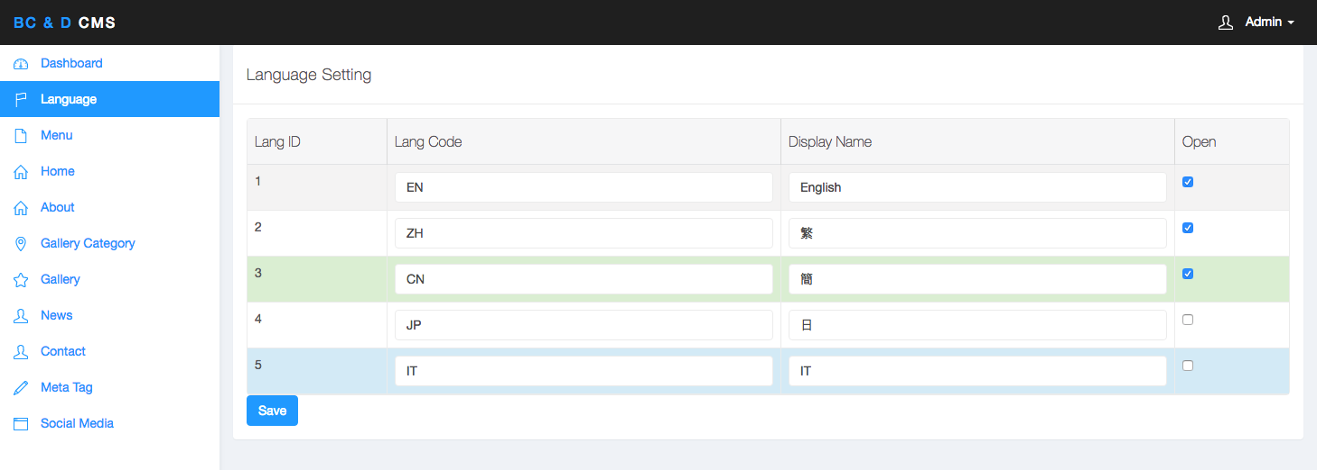

1. Maximum to 5 Languages in the website.
2. Lang Code - use on the SEO Path and Cookie to remember the user language preference.
3. Display Name – Show on Language Selection Menu
4. Open – checked Language will display on the Language Selection Menu.

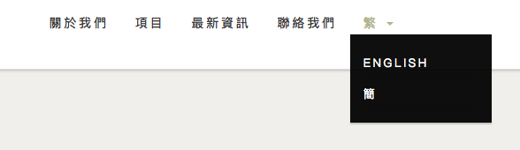

# Menu Setting

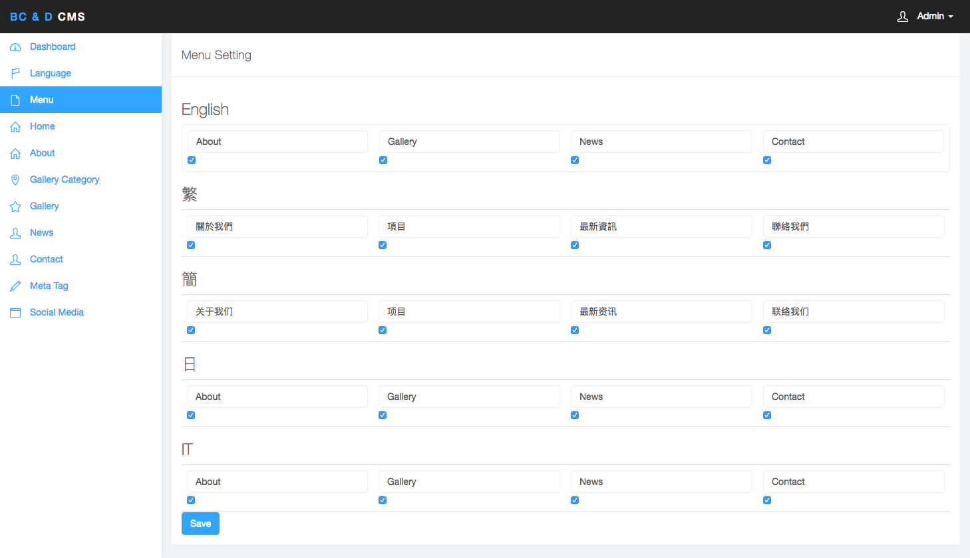

1. The languages depend on the setting on the Language Setting.
2. The menu name shows on the menu
3. Checked menu name will display on the menu

# Home Page Slider Setting

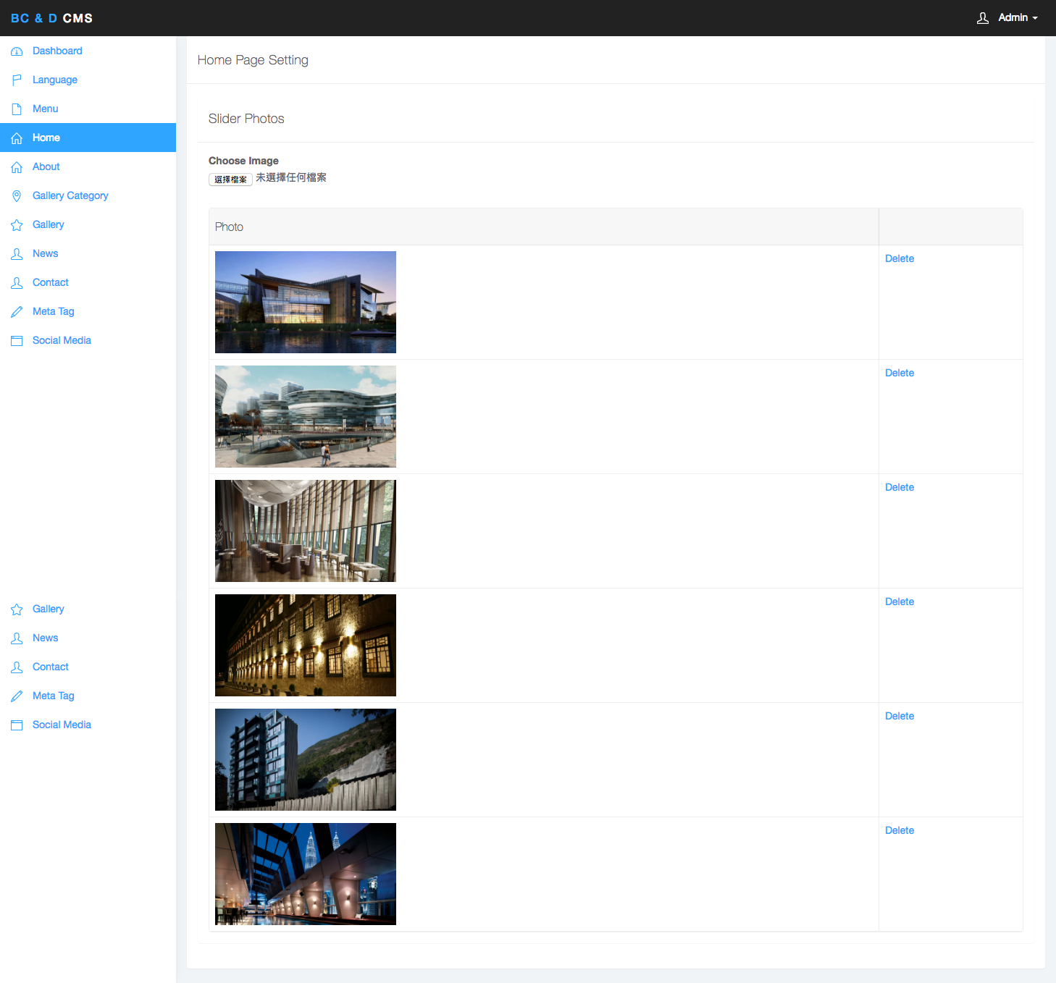

1. Click “choose image button” to choose any photos want to show on Home Page Slider. Maximum photo size is 5MB. After upload, the photos will publish automatically
2. Click “delete” will delete the photo permanently and won’t display on Home Page Slider.

# About Page Setting

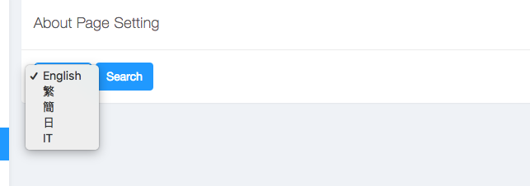

1. Select the language for the About Page Content.
2. The languages depend on the “Language Setting”
3. Click “Search Button” to edit content

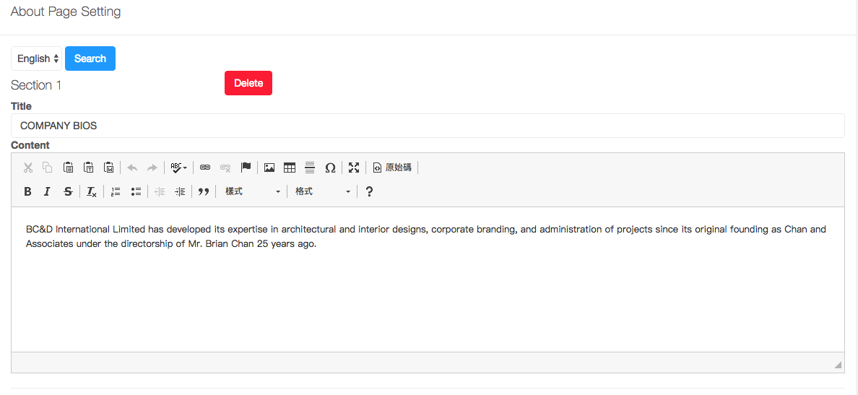

1. Edit the Content in every section.

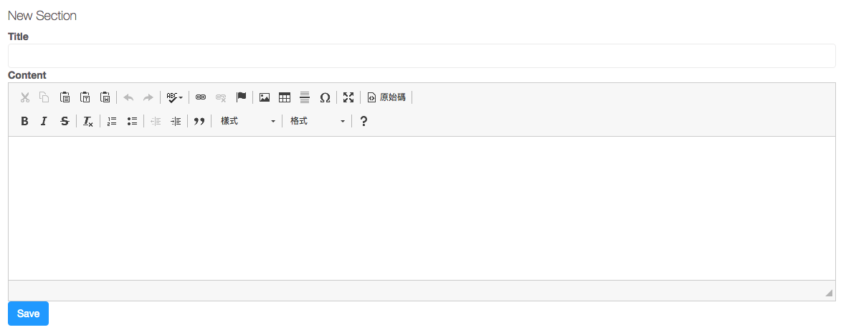

1. Input Content on the bottom “New Section”
2. Click “Save Button” of any update.

# Gallery Category Setting

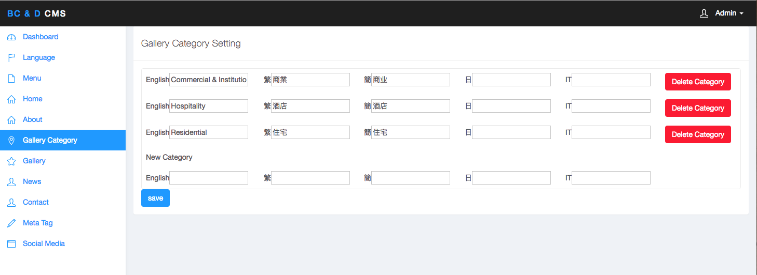

1. The “Gallery Category Language” depend on the “Language Setting”
2. Input Category Name in “New Category” and click “Save Button” to create new Gallery Category.
3. Any added Gallery Category will display on the Gallery Page
4. Click “Delete Category” to delete the Category. Any Projects under this Category will also delete.

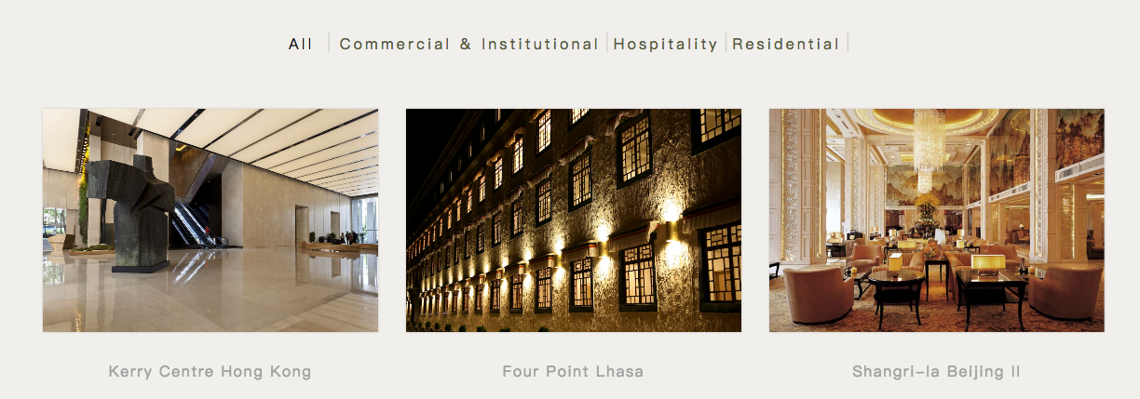

# Gallery Setting

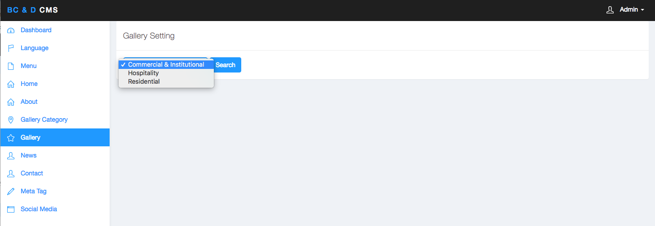

1. Choose the “Gallery Category” and Click “Search button” to view the projects

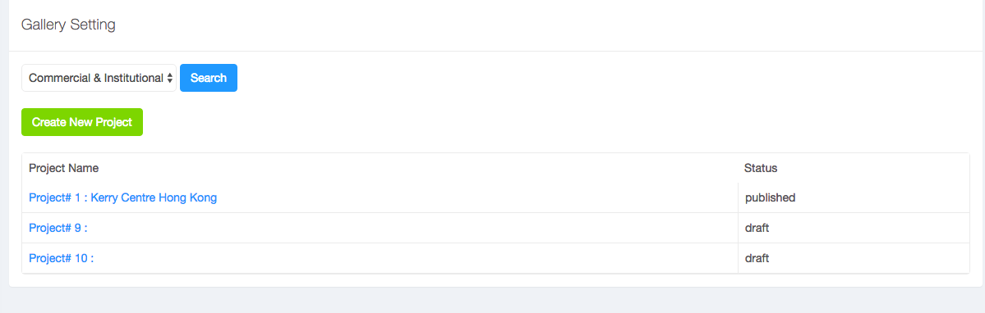

1. Click “Create New Project Button” to create New Project
2. The number following “Project #” is the Project Unique ID
3. If assigned Project Name, the Project Name will show following the “Project #”
4. The Status describes the Project Status.
5. “published” will display on Gallery Page.
6. “draft” will hidden on Gallery Page.
7. Click “Project #” to edit the project.



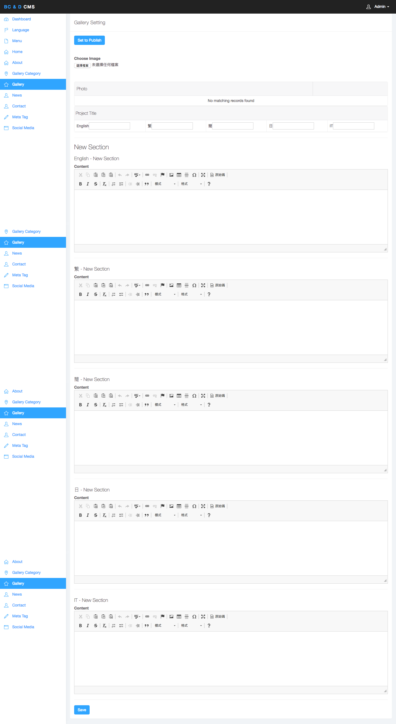

1. Click “Choose Image Button” to choose any photos show on the “Project Detail Page Slider”.
2. “Project Title” languages depend on the “Language Setting” setting.
3. Input content in “New Section” to create new section of Project.
4. Click “Save Button” to save any update.

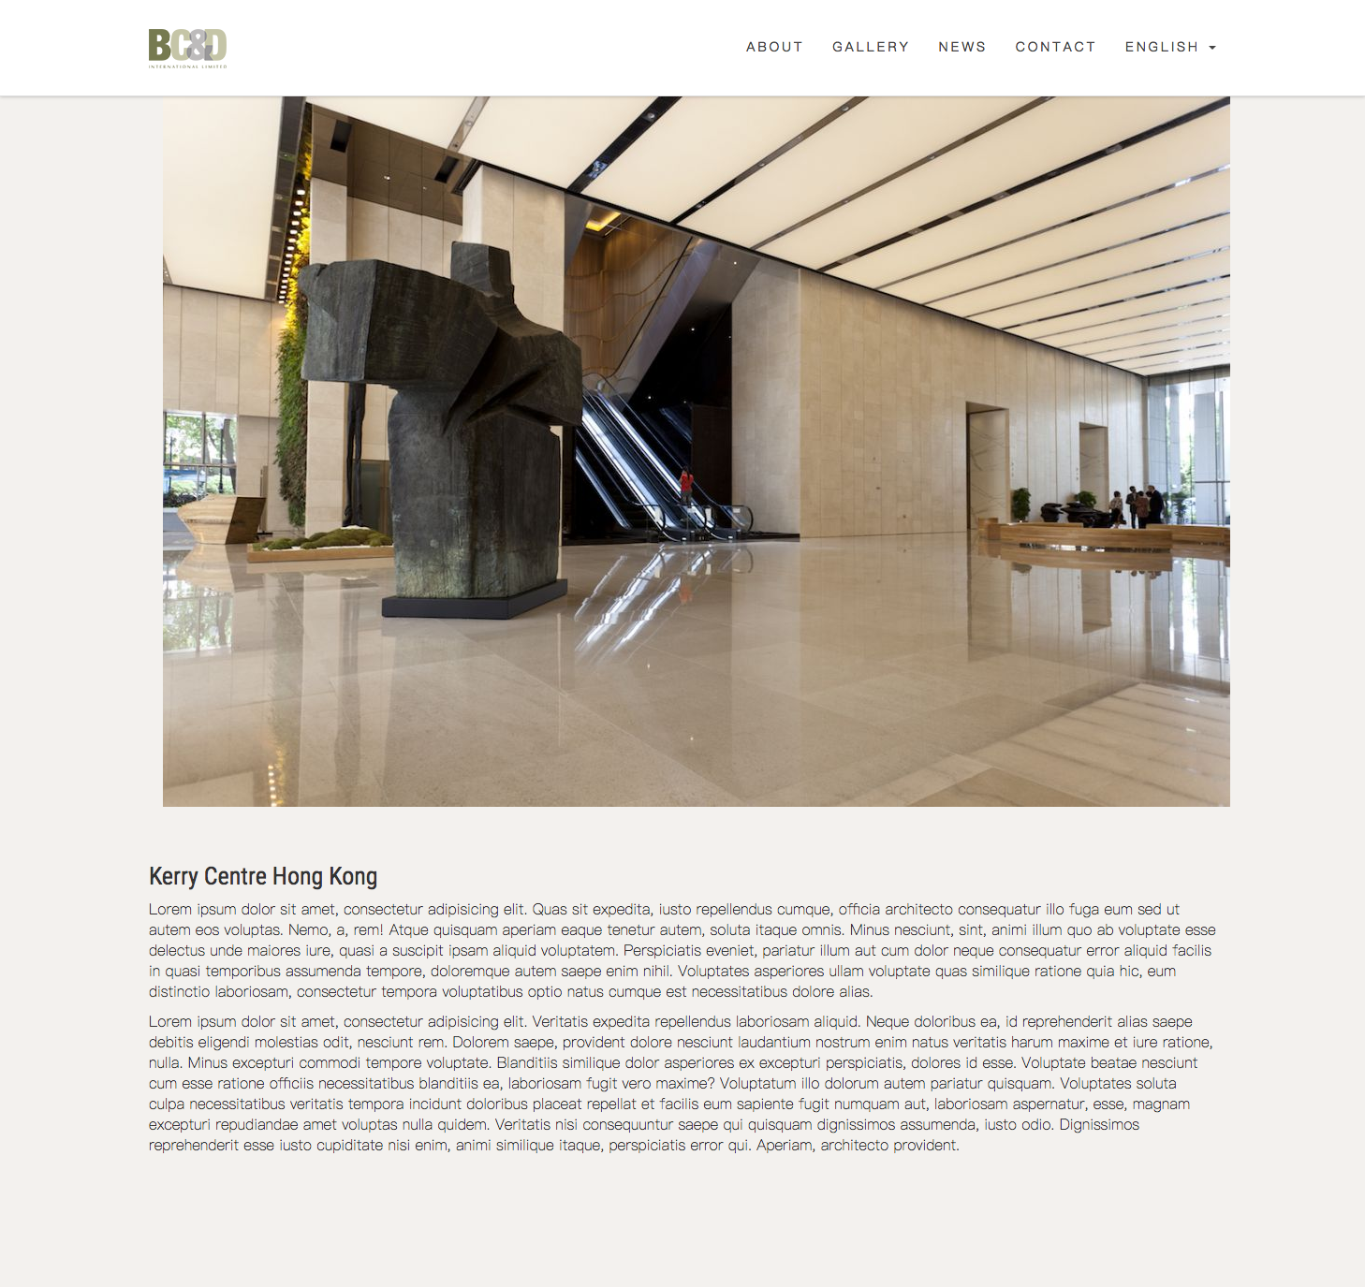

# News Setting

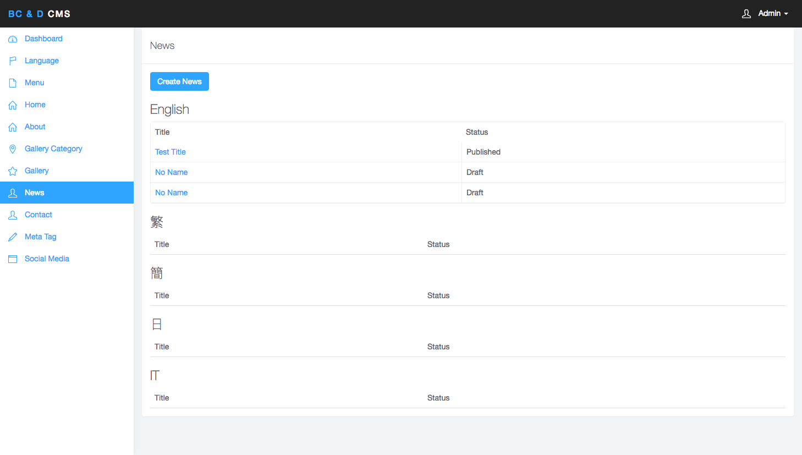

1. Click “Create News button” to create new “News”
2. The “News” article is under specific language.
3. Click “News Title” to edit the “News”
4. No “Title” article will use “No Name” to replace temporary. “No Name” only display on CMS.
5. The Status describes the “News” Status.
6. “published” will display on News Page.
7. “draft” will hidden on News Page.

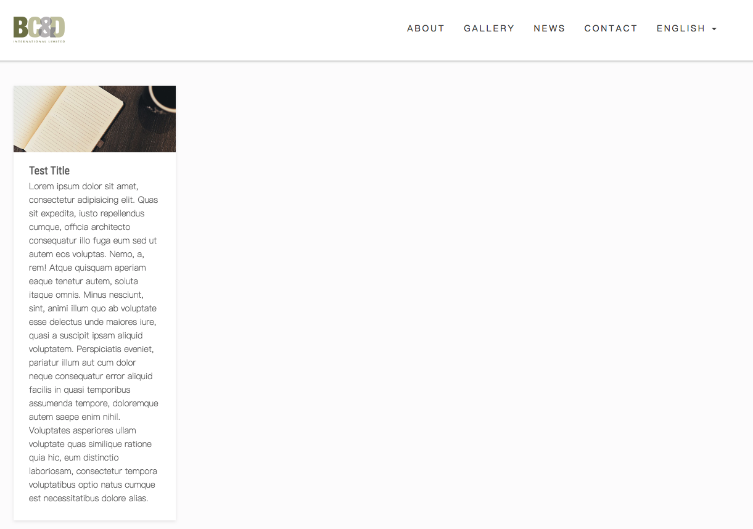

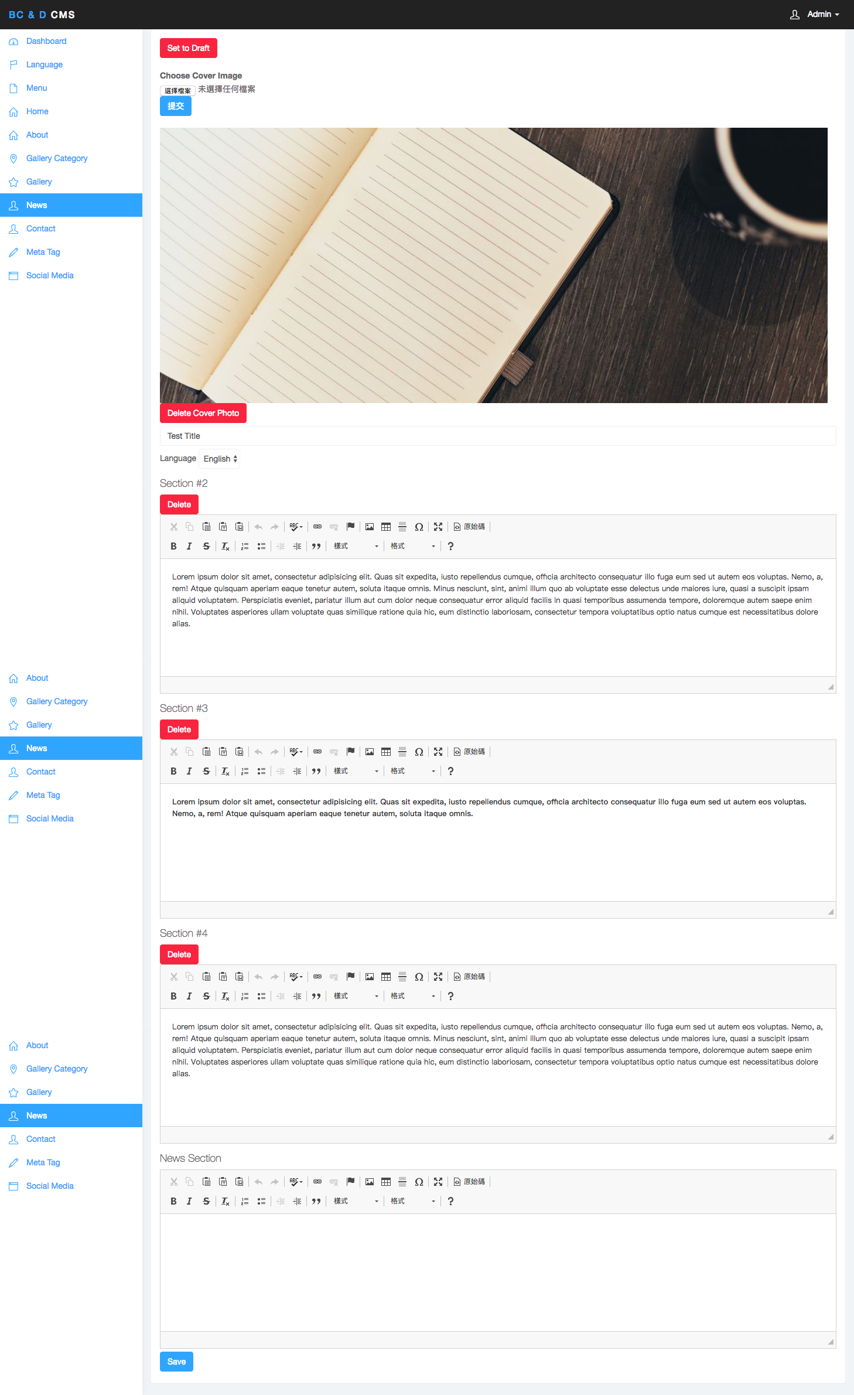

1. Choose “choose image button” to choose the cover image. Each “News” article only have 1 cover image.
2. Click “Delete Cover Photo” to Delete the Cover Photo.
3. Choose the “Language” of this article belongs to.
4. Input Content in “News Section” to create new section
5. Click “Save Button” to update any edit.

# Contact Setting

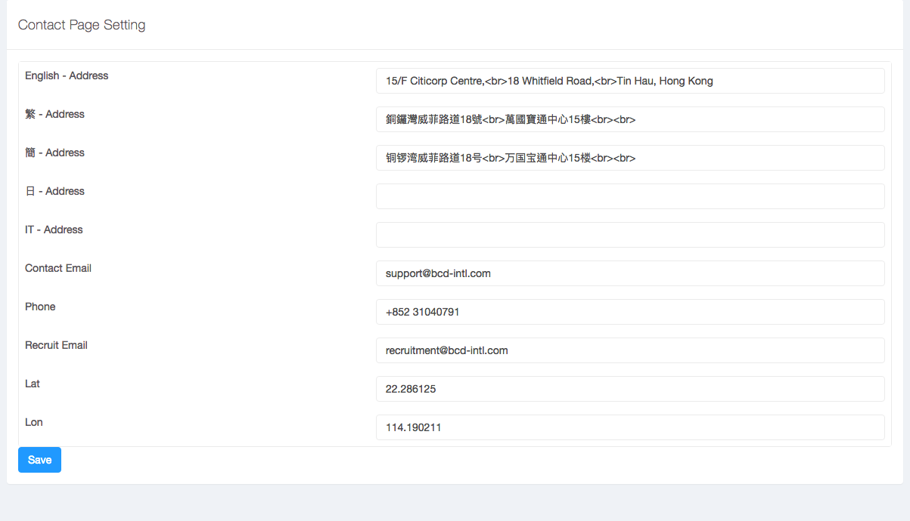

1. Address Language depend on “Language Setting”
2. “<br>” for breakdown the address.
3. Lat, Lon for define the position on Google map

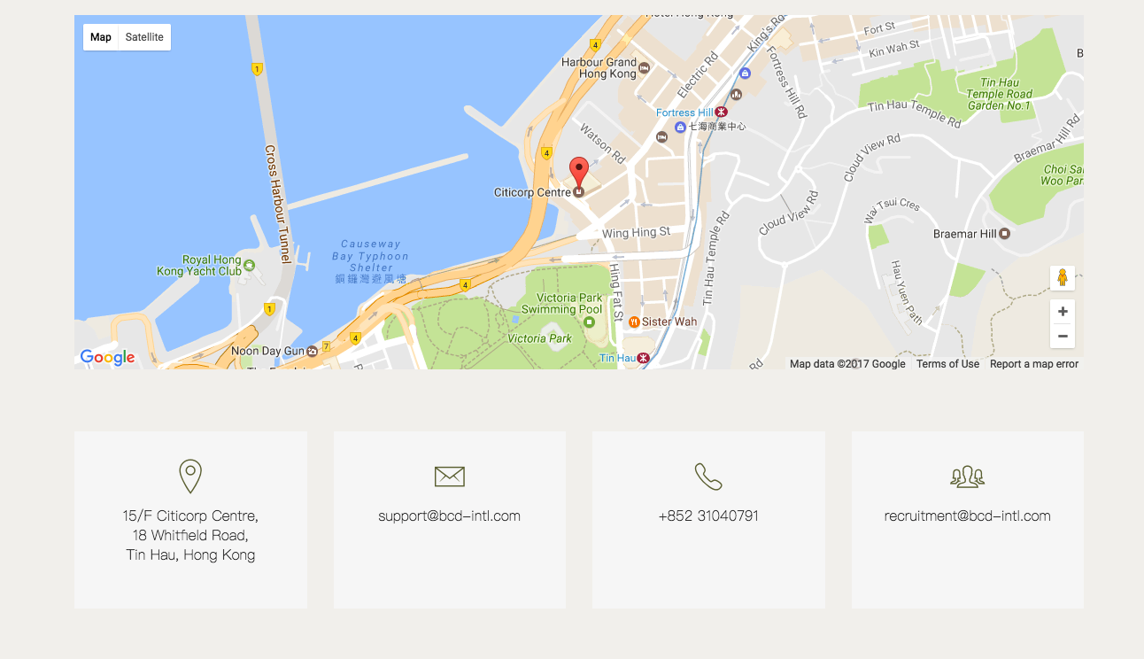

# Meta Tag Setting

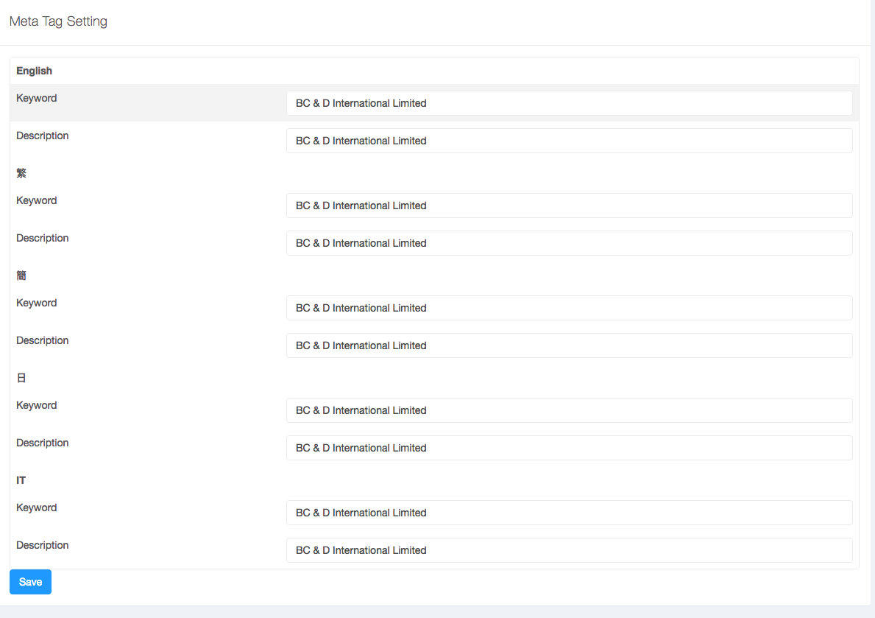

1. The Meta Tag Language depend on “Language Setting”
2. The Meta Tag use on SEO

# Social Media Setting

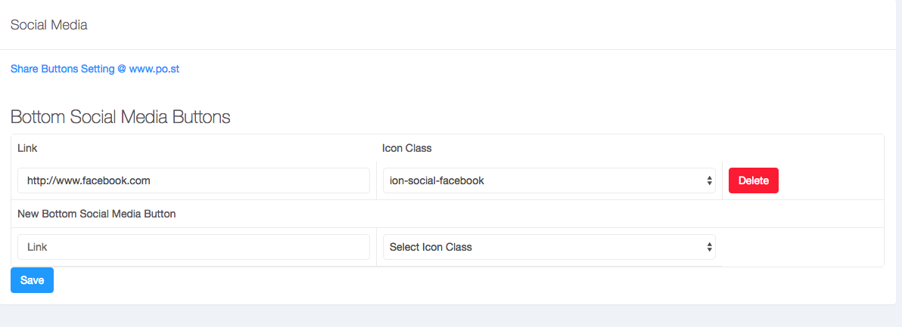

1. Click “Share Buttons Setting @www.po.st” to set the “share button” on Project/News Article Page.
2. Input “Social Media Page” Url on “Link” field and select the preset icon.
3. Click “Save Button” on any update.
4. The “Social Media button” will display on bottom of every page.

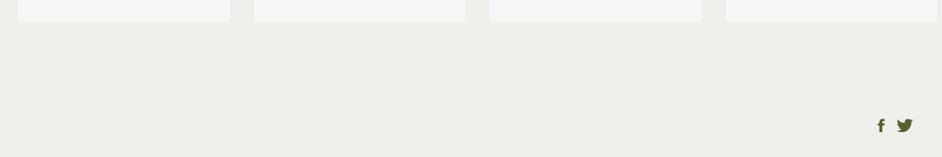

# [www.po.st](http://www.po.st) Setting

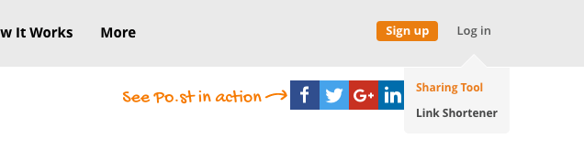

1. Mouse over “Log in” and Click “Sharing Tool”
2. Login
3. After login, click “Social Tools”

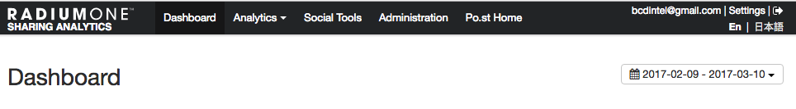

1. Click “Set up and activate”

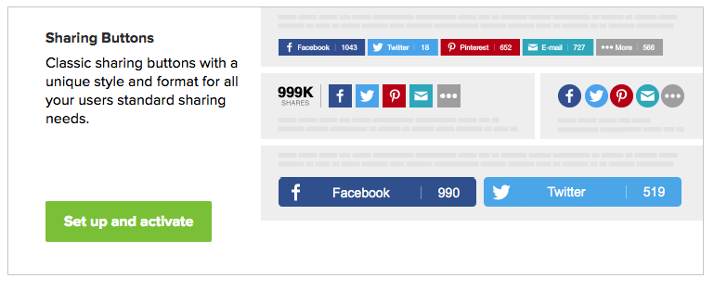

1. Choose the settings and click “Save & Active” at the bottom. Wait 2 – 5 minutes, the “share button” will display on both Project /News Article Page.

